OUTLINE

TITLE OF THE PROJECT

NAME OF THE APPLICANT LOCAL / REGIONAL GOVERNMENT

CITY / COUNTRY

Deadline for the reception of applications: 16 March 2018
Please return this application form to award@agenda21culture.net
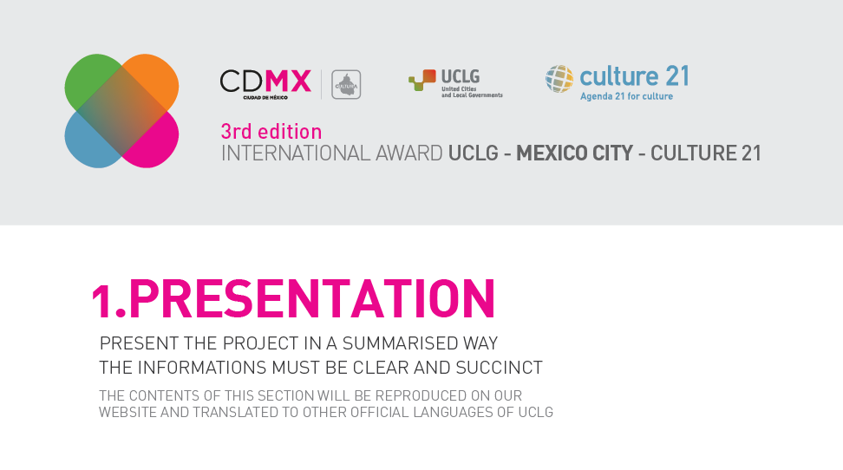

1.1. Title
NOTE. You should only write the title of the policy, programme or project.

1.2. Brief description
NOTE. You should present the overall policy, programme or project, in a maximum of 300 words.

1.3. Duration
NOTE. It is necessary to explain the start and end dates of the policy, programme or project, indicating if it is a completed initiative, one in progress, or otherwise indicating its timeline.
Start date

End date (only if it has finished)

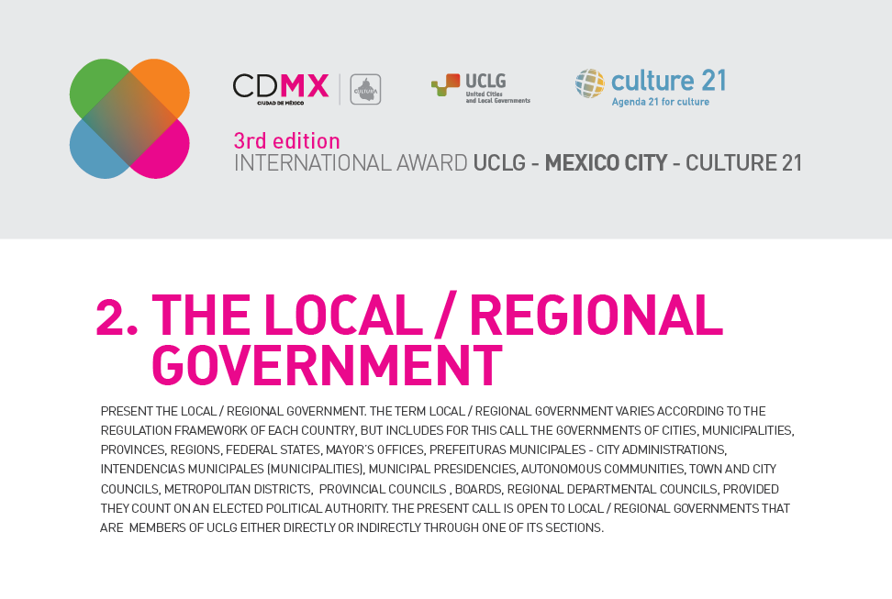

2.1. Name of the applicant local /regional government

2.2. Details of the Mayor or Head of the local/regional government
NOTE. Write here the details of the mayor or head of local/regional government. All fields are mandatory. These details should correspond exactly to the details that appear in the letter of presentation or annex A.
Name
Position
Address
City
Country, province and state
Telephone
E-mail
Website

2.3. Details of the person responsible for the bid
NOTE. The person responsible for the bid is the person that has written all the sections of this form and knows the bid in depth. All fields are mandatory. It should be an executive person in the organisation chart of the local/regional government, and who will be the main contact person with the organisers of the Award.
Name
Position
Address
City
Country, province and state
Telephone
E-mail

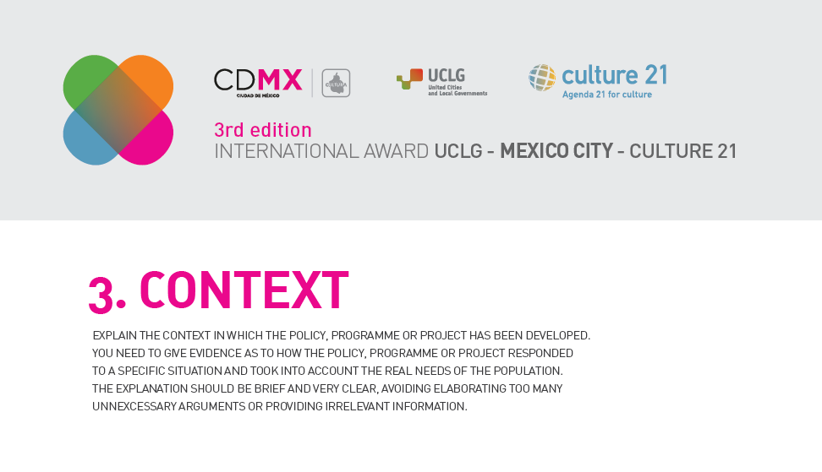

3.1. Description of the city / territory where the project has been developed
NOTE. You should present the situation in the city / territory where the project was developed, in a maximum of 200 words.

3.2. Background of the policy or project
NOTE. You should present the background to the policy, programme or project, in a maximum of 400 words.
The explanation should respond to these questions:
- What is the general framework of local cultural policies in the city or region? How does this relate to the policy, programme or project described here?
- Who started the project? Why?
- What need, problem or gap did it aim to address?
- In what way is the programme or project coherent with the development policies of your city?

3.3. Relation of the policy, programme or project with global agendas
NOTE. You should give evidence that there exists a relation between the project and the Agenda 21 for culture (see www.agenda21culture.net), on the one hand, and with the UN 2030 Agenda / Sustainable Development Goals (see https://sustainabledevelopment.un.org/post2015/transformingourworld) on the other. You may also include references to other relevant global or regional agendas on culture or sustainable development. You should describe this precisely, in a maximum of 400 words.

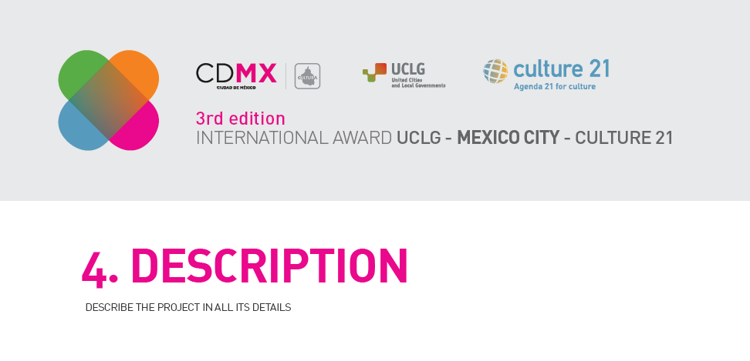

4.1. General aim
NOTE. There should only be one general aim. In this section you should explain in a simple, very synthetic and concise way, what the general aim of the policy, programme or project is, in a maximum of 150 words.

4.2. Description
NOTE. In this section you should describe the policy, programme or project. The maximum length is 1,200 words. As general guidance, you may consider the following elements:
- Specific goals
- Beneficiary population
- Main actions carried out
- Phases
- Partner entities (e.g. if NGOs, other civil society organisations, private companies or groups of citizens have been involved, and how)
- Other partner governments (e.g. if regional/provincial/state or national/federal governments have been involved, and how)
- Budget
- Obstacles faced in the implementation
- Results

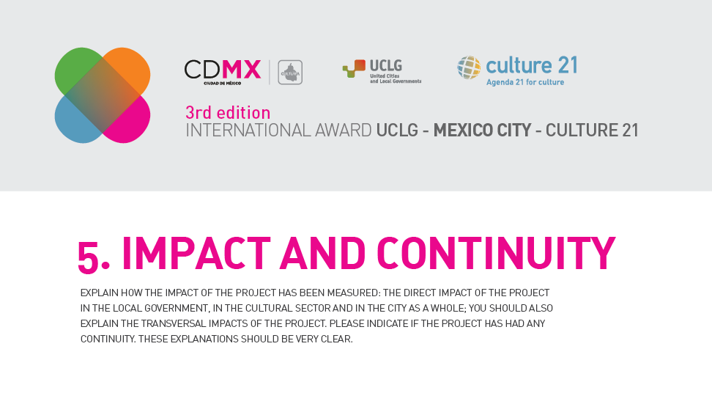

5.1. Impacts
NOTE. Give evidence of the impact of the project for the local government, for the cultural sector and for the city as a whole. The following aspects should be addressed in your responses:
- Impact on the local government: how has the local government changed as a result of the project?
- Impact on the culture and the cultural actors of the city or region
- Broader impact on the city / region and its population. You may refer here to impacts in the exercise of rights, gender equality, and other economic, social and environmental aspects.

The maximum length is 400 words.

5.2. Evaluation
NOTE. You should explain whether any evaluation mechanism for the policy, programme or project has been planned. In this case, the methodology and indicators applied as well as the results obtained should be described. Answers should be of a maximum of 200 words.

5.3. Key aspects
NOTE. You should describe the key aspects which serve to explain, in your view, the effectiveness of the policy, programme or project that is the object of this application. Answers should be of a maximum of 200 words.

5.4. Continuity
NOTE. Provide information about the way in which the local government has given continuity to a completed project, or foresees giving continuity to a project in progress. You can give details about the organisation, technical and financial dimension of this continuity in a maximum of 200 words.

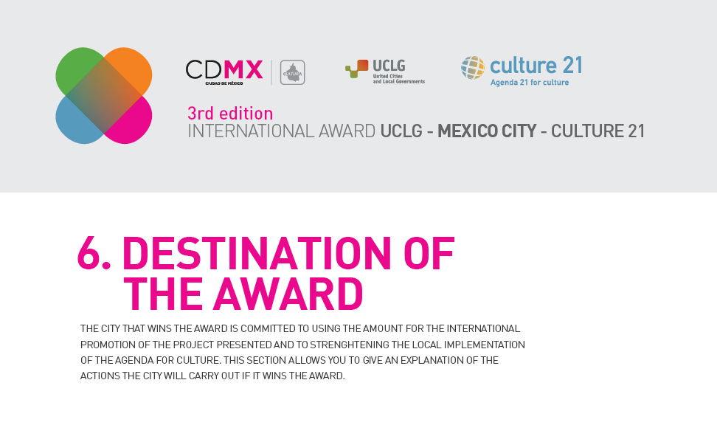

6.1. Local and international promotion
NOTE. Describe the actions of local and international promotion foreseen by the local government, if the city is awarded the prize, in a maximum of 300 words.
Local and international promotion

6.2. Local implementation of the Agenda 21 for culture
NOTE. In this section you should describe the actions for the strengthening of the local implementation of the Agenda 21 for culture, if the city is awarded the prize, in a maximum of 200 words.
Strengthening of local implementation of the Agenda 21 for culture

6.3. Budget
NOTE. In broad headings, include the details of the budget dedicated to each of the actions and sub-actions of sections 6.1. and 6.2. All items above Euro 5,000 should be detailed.
Budget

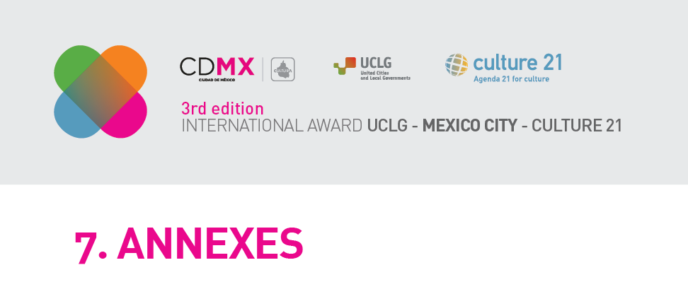

OBLIGATORY ANNEX
A letter of presentation signed by the mayor or head of the government who will lead the whole bid.
A. Letter of presentation of the mayor, with free structure and contents, although one paragraph should be dedicated to summing up the project (summarising section 1), another should outline how the city will use the funds of the Award (summarising section 6) and another paragraph that mentions the membership in UCLG.

PHOTOGRAPHS

At least 3 photographs in high quality (minimum 150ppp; JPEG, PNG, TIFF or similar format) need to be enclosed alongside the application.

OPTIONAL ANNEXES
(List here the complementary documents included with your bid, a maximum of 3 documents, either text, videos or multimedia).

